CE321 Network Engineering:

SDN Tutorial

Dr Martin Reed v1.4 5th September 2023

**NOTE: this laboratory is a demonstration of the new SDN material introduced in the 2019/20 academic year. This supports the content regarding software defined networking in the Cisco Courseware. This material goes beyond that material so that you can see an SDN system in action. SDN is also now being widely deployed and employers are increasingly interested in graduates having this knowledge.**

# **1. Introduction**

Software defined networking (SDN) can be an umbrella term encompassing a number of systems that configure networks using software (including something called SD-WAN which is quite different from the contents of this lab). Here we will use it in its a narrower sense to mean:

*Network switches under the control of a centralised software controller where the switches and controller communicate using the OpenFlow protocol. Through the use of this architecture existing protocols running on the switches (e.g. spanning tree protocol and/or routing protocols) are replaced by the central controller.*

This tutorial gives some examples of SDN in a small network to show its benefits and costs. It uses a Virtual Machine which contains a controller (ONOS <https://onosproject.org/>) and a network that is emulated using Mininet (<http://mininet.org/>). Although the network is emulated and running on a single Virtual Machine, this does not make it less “real,” in practice many cloud services running on Linux systems use the same Open vSwitch switches as used in the Mininet topology. This tutorial is meant to be performed in about two hours to:

* give a brief introduction to SDN through seeing an SDN network in action.
* perform some experiments to show the benefits and costs of SDN.
* show how the code in the SDN controller influences the action of switching.
* give opportunities for further exploration beyond this tutorial.

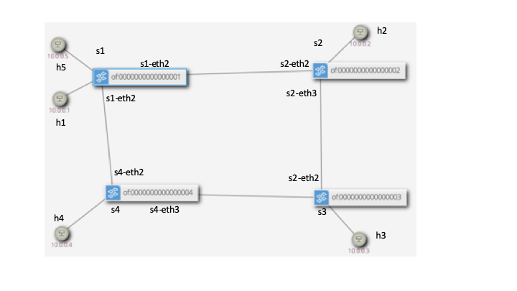

**Figure 1 Network Topology**

The test network is shown in Figure 1. Note that hosts have simple to remember MAC and IP addresses of the format 10.0.0.X and 0A:00:00:00:00:0X where X is replaced by the host number.

## 1.1. Passwords

**Virtual machine:**

Username: ce321

Password: networks

ce321 account has passwordless sudo privileges *i.e.* it can carry out root level commands using sudo <command> without a password, this would be a severe security hazard in a real computer!

**SDN controller**

Username: onos

Password: rocks

Again, not good examples of security!

# 2. Exploring the basic network

## 2.1. Starting the Controller and Basic Topology

**NOTE: this uses the Linux command line you will need to start a terminal using the top left launcher icon and “Terminal Emulator”**

Start the VM and start the controller:

Command line:

cd ~/sdn-demo

./start-onos

It is ready when you see (after about 1 minute):

<some number> - org.onosproject.onos-core-primitives - 2.7.0 | Updated node 127.0.0.1 state to READY

Wait until you see the ONOS server output stop (about 30 seconds, wait until the scrolling output stops). **NOTE you must leave this terminal running, you will need to start a new Terminal Emulator for later commands.**

Then start the basic topology (the -s means run it as SDN, later we will run it in STP mode):

Command line:

cd ~/sdn-demo

sudo python3 test-network.py -s

After some time to settle it will start the *Mininet* command line which allows you to interact with the Mininet network emulation system. This is feature-rich, but we will only be using the basic facilities.

Start by trying to ping between h1 and h2 and note it fails (use Ctrl-c to finish a ping):

mininet> h1 ping h2

PING 10.0.0.2 (10.0.0.2) 56(84) bytes of data.

From 10.0.0.1 icmp_seq=1 Destination Host Unreachable

….

This fails as we have a running controller, but it does not have any running SDN applications yet. **Again leave this program running for the moment unless you are told to finish it with “Exit”.**

Open the GUI for the controller using (username ONOS; password rocks) in Firefox:

<http://localhost:8181/onos/ui>

This may say “No devices are connected” (depending on what is running by default from the last time it was run).

Open the ONOS console (**in a new Terminal Emulator window)** (if you want to quit it, use Ctrl-d) (password: rocks) app:

Command line:

cd ~/onos-demo

./onos-shell

(password is rocks)

(note the onos-shell command simply connects to the Onos controller using ssh)

In the ONOS console start the applications that we need (note the onos@root prompt):

onos@root> app activate org.onosproject.openflow

onos@root> app activate org.onosproject.fwd

The first command enables the controller to use the OpenFlow protocol to communicate with the switches. The second implements a basic forwarding application that will insert *flow rules* into the controller to implement basic Ethernet MAC based switching (but not the same as the basic MAC table implemented in traditional Ethernet switching). Note loading these applications will also automatically load other needed SDN applications.

You should now see some devices in the Firefox window. Use the key-strokes **h** and **l** (lower case L) to toggle showing hosts and labels (this will be useful later).

Again ping between h1 and h2 and note it succeeds (use Ctr**l**-c to finish a ping):

mininet> h1 ping h2

PING 10.0.0.2 (10.0.0.2) 56(84) bytes of data.

64 bytes from 10.0.0.2: icmp_seq=1 ttl=64 time=14.6 ms

64 bytes from 10.0.0.2: icmp_seq=2 ttl=64 time=10.0 ms

64 bytes from 10.0.0.2: icmp_seq=3 ttl=64 time=0.500 ms

64 bytes from 10.0.0.2: icmp_seq=4 ttl=64 time=0.051 ms

^C

--- 10.0.0.2 ping statistics ---

4 packets transmitted, 4 received, 0% packet loss, time 3012ms

rtt min/avg/max/mdev = 0.051/6.312/14.652/6.254 ms

This should succeed, as above, if it does not please see a lab demonstrator.

Now you should see the network topology in the ONOS GUI in Firefox. You will probably only see hosts h1 and h2 unless you have sent traffic to other hosts. Note you may need to use **h** and **l** keys to toggle showing the hosts and labels.

## 2.2. Observing the data plane flow rules

Wait at least 15 seconds without any traffic running in the network (ie after your ping above, or any other tests you perform later), now look at the flow rules in the switch s1 in a terminal (**you will need to open a new terminal for this, it will not work** **in the ONOS console nor the Mininet console.**)

sdn@sdn:~$ cd ~/sdn-demo

sdn@sdn:~/sdn-demo$ ./show-flows-in-switch 1

cookie=0x10000021b41dc, duration=397.615s, table=0, n_packets=5, n_bytes=490,

priority=5,ip actions=CONTROLLER:65535

cookie=0x100009465555a, duration=397.615s, table=0, n_packets=257, n_bytes=35723, priority=40000,dl_type=0x88cc actions=CONTROLLER:65535

cookie=0x10000ea6f4b8e, duration=397.615s, table=0, n_packets=8, n_bytes=336,

priority=40000,arp actions=CONTROLLER:65535

cookie=0x100007a585b6f, duration=397.614s, table=0, n_packets=257, n_bytes=35723, priority=40000,dl_type=0x8942 actions=CONTROLLER:65535

This contains only four flow-rules, the first line of each is basically some statistics and identifiers, please ignore this, for now. The second part is more interesting. The first means “if an IP packet arrives in the switch then send it to the ONOS controller.” The others are similar except for other types of Ethernet frames, the third is for ARP packets, the other two are for two discovery protocols used in the network. These four rules are placed in all the network switches start up by the controller so that frames from all “unknown” flows are sent to the controller. Note that the flow rules have a priority: a frame is compared to the list of flow rules in order (highest number priority first) until one matches, the associated action is performed, then the frame is not compared to any other rules.

Now start the ping between h1 and h2 again, leaving it going for the moment while you look again at the flows in s1, you will see two new rules (the other four will still be there):

cookie=0x1300006e01dc4b, duration=18.437s, table=0, n_packets=17, n_bytes=1666, priority=10,in_port="s1-eth1",dl_src=0a:00:00:00:00:01,dl_dst=0a:00:00:00:00:02 actions=output:"s1-eth2"

cookie=0x13000052014fde, duration=18.434s, table=0, n_packets=17, n_bytes=1666, priority=10,in_port="s1-eth2",dl_src=0a:00:00:00:00:02,dl_dst=0a:00:00:00:00:01 actions=output:"s1-eth1"

These two rules were inserted by the ONOS *fwd* application as a result of the first frame being sent to the controller. We can now describe the rules in more detail. Consider the following portion of the first of the above rules:

in_port="s1-eth1",dl_src=0a:00:00:00:00:01,dl_dst=0a:00:00:00:00:02 actions=output:"s1-eth2"

This has two parts: the first is the *selector:*

in_port="s1-eth1",dl_src=0a:00:00:00:00:01,dl_dst=0a:00:00:00:00:02

This matches the input port, Ethernet source and Ethernet destination, but it could also match things like Ethertype, IP addresses, TCP/UDP ports (ie most things in the headers).

The second part is the *action:*

actions=output:"s1-eth2"

Which means send it out the second port (called s1-eth2), but it could have other actions such as changing the addresses (e.g. for network address translation), adding a VLAN tag, or even resubmit the frame to another switch table for further processing.

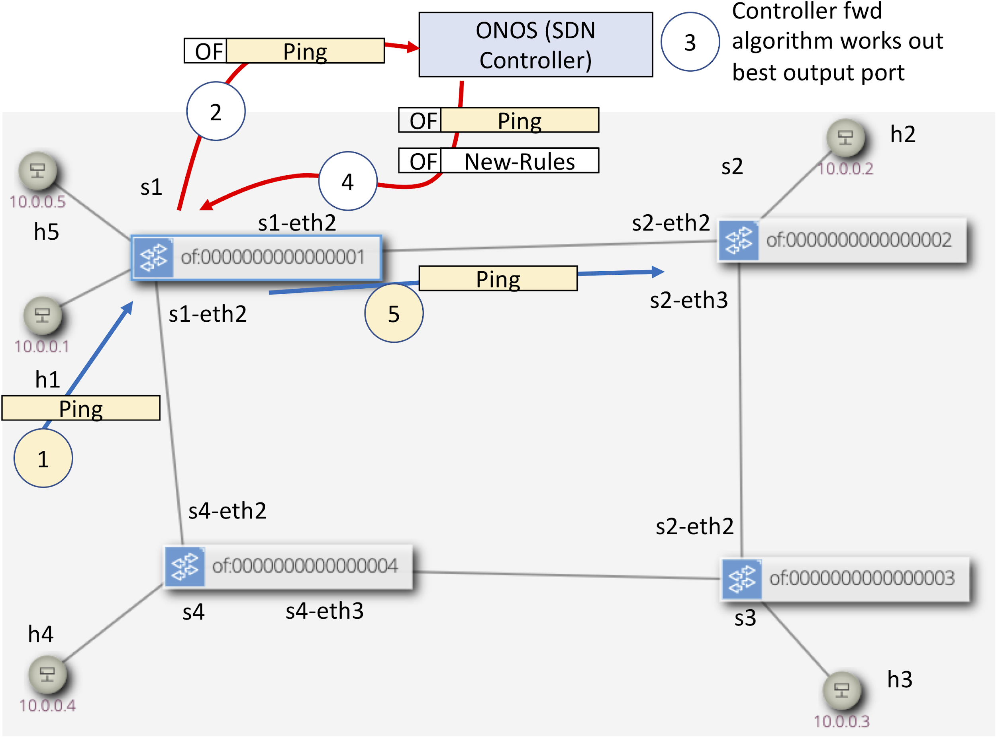

**Figure 2 SDN steps on the first Ping packet between h1 and h2, note data plane and control plane actions are coloured differently**

Figure 2 illustrates and breaks these steps down:

1. The ping is sent from h1 to s1 (we are skipping the ARP message, assuming this has already happened)
2. S1 looks in the flow table and finds no specific rule so it matches the “cath all” ip rule to send frames to the controller. It sends the whole ping packet to the controller as the contents of an OpenFlow message.
3. The application in the controller (in this case called fwd) works out the best output port
4. The controller sends the ping packet back to the switch, again in an OpenFlow message, but this time it also has the instruction on what the switch should do with it (send out port 2). It also sends some other OpenFlow messages to insert new rules in the switch (as you have seen above).
5. The switch now sends the frame out of the indicated port (2) and inserts the rules in the switch.
6. (not shown) the same as above will be performed in s2
7. (not shown) future frames in the flow will not be sent to the controller while the rules exist.
8. (not shown) when the flow of packets stops the switches delete the flows without telling the controller. (The timeout is 10s).

If this sounds complex, well yes, it is. However, note that it only happens on the first frames, once the two rules have been inserted at priority 10 any subsequent frames are switched directly by the rules without intervention from the switch; the catch-all IP rule is at a lower priority of 5.

There are some key differences between this method and “traditional” Ethernet switching apart from the obvious steps above:

* SDN separates the *control plane* from the *data plane*. We no longer have spanning tree protocol (STP) and routing protocols performing the control plane in the same links as the data plane, OpenFlow goes over a separate network (at least in this simple story). Instead of the control plane being distributed, it runs in a central controller.
* The switching (in this application) inserts rules that match both source and destination MAC addresses; whereas in traditional Ethernet switches the MAC address table only contains destination addresses. You may see why this is important later.

While the ping is still going on look at the flow tables in the other three switches and record the path that the pings between h1 and h2 go over.

So now you have seen the basics of SDN. However, we cannot use this to say how every SDN network operates, it will depend on the application loaded into the controller, in this case one called *fwd*. If a different application is run the story might be slightly (or even wildly) different.

# 3. Comparing the performance of SDN vs STP controlled network

Now we will compare both and SDN and STP controlled network by carrying out some very basic experiments (each test is available from the Mininet command line in the test_network script. Here is a summary of the tests, we will use them in slightly different ways and running the tests can be automated as described after the summary:

test1 : send a TCP flow between h1 and h2 as quickly as possible and report throughput.

test2 : send a TCP flow between h1 and h2 as quickly as possible while simultaneously sending between h4 and h3 and report throughput.

test3: send a TCP flow between h1 and h2 as quickly as possible while simultaneously sending between h5 and h2 and report throughput.

test4: clear the ARP caches in h4 and h3, wait for the flow-tables to clear in the switches, then send 10 pings between h4 and h3.

test5 : fill the ARP caches in h4 and h3 (by sending an initial ping which is not shown), wait for the flow-tables to clear in the switches, then send 10 pings between h4 and h3.

These are some basic tests that will allow us to test some basic differences between SDN and STP in practice, they are by no means exhaustive. Note that the timings and bit rates observed will be highly dependent on what else is running and the OS/CPU caching mechanisms. Try not to run anything else while running the tests and keep the virtual machine desktop in focus all the time. The capacity of all the links between the switches has been limited to approximately 10 Mb/s, but the mechanism to do this limitation is not exact and you may see traffic above this level.

## 3.1. SDN performance experiments

Close the existing Mininet console or type “exit” to finish it (the script will disable old scripts but this is not obvious in the old scripts you might leave lying around). BUT LEAVE THE ONOS CONTROLLER TERMINAL STILL RUNNING

You can either run the tests from an existing Mininet window (test1, test2 etc.) or simply run the automated tests in order:

Command line:

cd ~/sdn-demo

sudo python3 test-network.py -s -t

The -t flag (“text” mode) tells the script to run all five tests in order.

Record the output of the five tests (copying from the command line will be easiest).

When they have finished confirm the path taken by the (h1, h2), (h4,h3) and (h5,h2) traffic flows by launching a ping between one pair at a time and looking at the switch flow tables.

## 3.2. STP performance experiments

Again, close any existing Mininet processes (“exit” or close the terminal window).

You can either run the tests from an existing Mininet window (test1, test2 etc.) or simply run the automated tests in order:

Command line:

cd ~/sdn-demo

sudo python3 test-network.py -n -t

The -n flag (“normal” mode) tells the script to run the switches in “standalone” mode without the controller and instead uses Spanning Tree Protocol (actually RSTP) as the control plane.

Record the output of the five tests (copying from the command line will be easiest).

Note that when the script started (ie above the tests), it lists the STP role of each port. Record this and thus work out the path taken by the (h1, h2), (h4,h3) and (h5,h2) traffic flows. You can also see the switching tables by looking at the MAC address tables in the switches, for example in s1 (only showing relevant entries):

sdn@sdn:~$ sudo ovs-appctl fdb/show s1

port VLAN MAC Age

2 0 0a:00:00:00:00:04 0

3 0 0a:00:00:00:00:01 0

2 0 0a:00:00:00:00:05 0

2 0 0a:00:00:00:00:03 0

3 0 0a:00:00:00:00:02 0

If you need a reminder about STP port roles and how Ethenet uses MAC address tables, look it up in your previous course notes or look it up on a source such as Wikipedia. In brief: STP works to stop any switching loops by “turning off” selected ports to stop the loops (alternate ports in RSTP); the MAC address table is populated as frames appear in the switches and records which port to send frames that match that particular destination MAC address.

## 3.3. Your conclusions from your experiments?

Compare your results from the tests run in the two scenarios SDN vs STP, what do you conclude about:

* Choice of paths and advantages/disadvantages this may bring?
* Why does SDN need to take note of both source and destination frame MAC addresses while STP only records the destination address in its MAC address table?
* If there are N devices in the network how big can the following become:
  + the number of flow entries in each switch in the case of SDN?
  + the number of MAC addresses in the MAC address table in the case of STP?
* Delays, in particular in the first packet in a flow?

One of the big reasons SDN has been deployed in data centres is that it can get approximately 40% more traffic in the network compared to a simple STP deployment. Can you see why from the (highly contrived) example network shown in Figure 3? You will need to consider which ports are in alternate mode (for RSTP) and add up the traffic available from links that do not have an alternate port on one end.

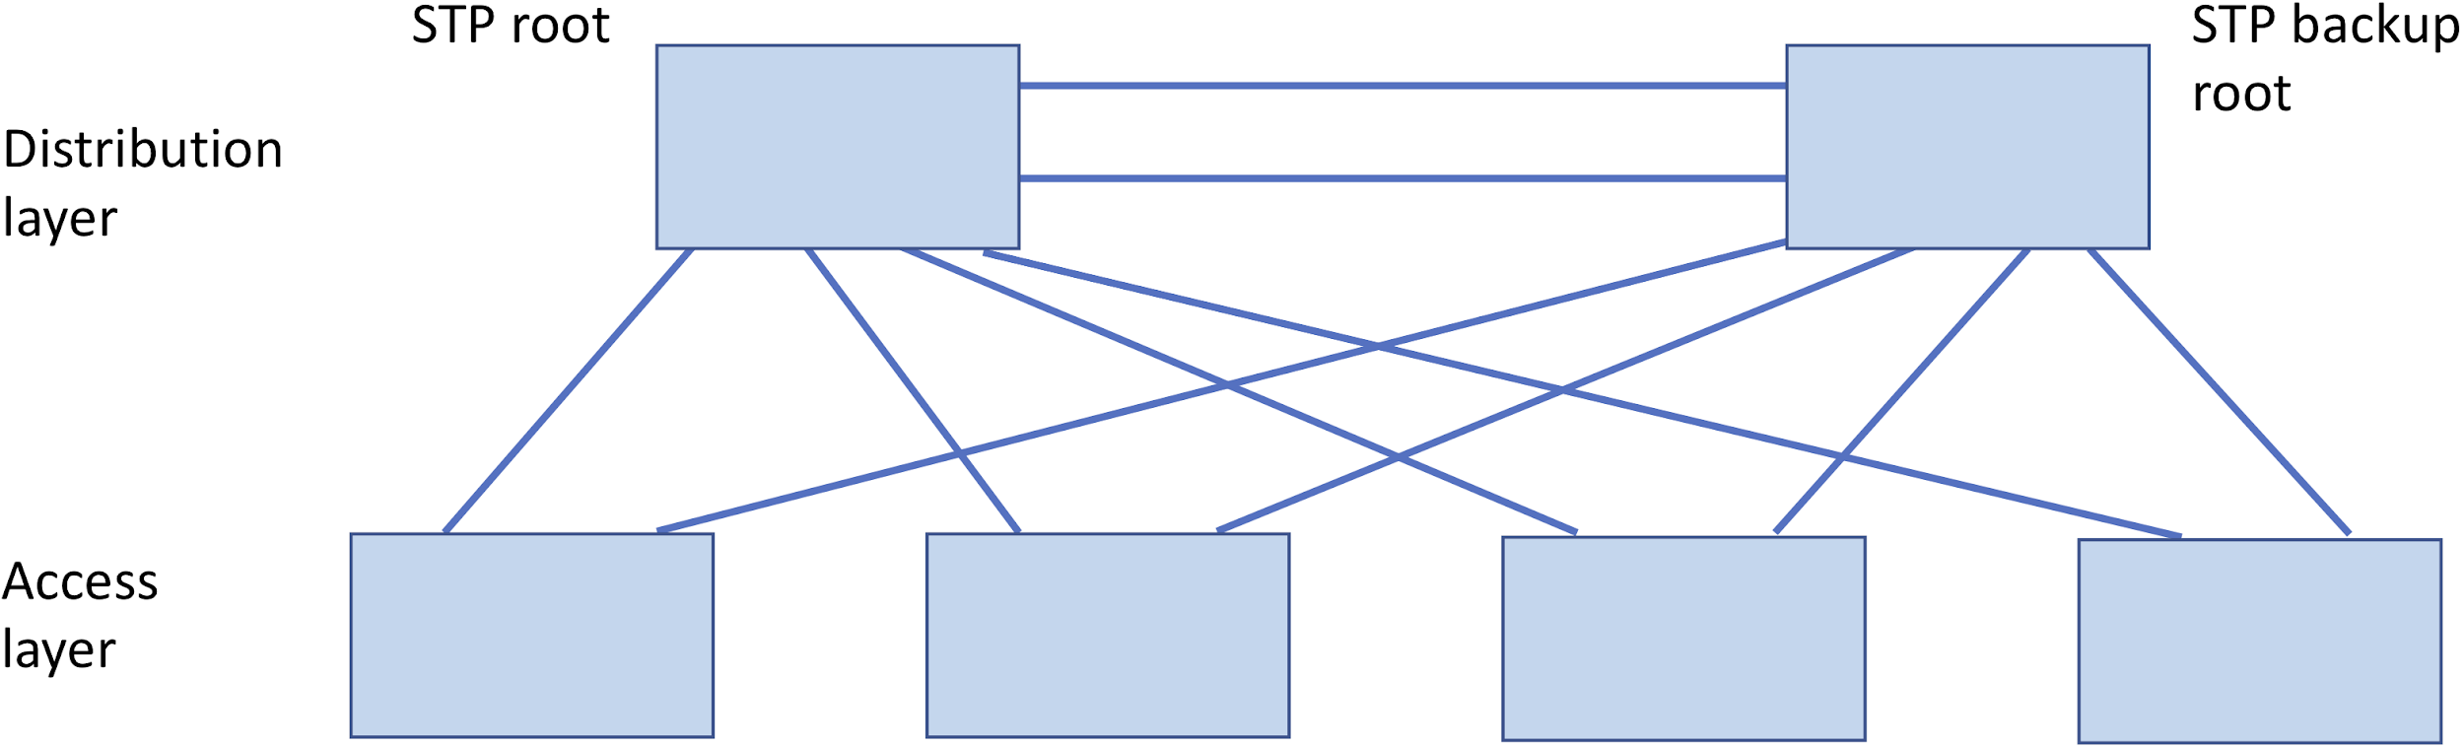

**Figure 3 Stylised Data Centre network with four access layer switches and two distribution layer switches, consider which ports will be alternate in this topology?**

# 4. Network Programming

The real power with SDN is that the network can now be “programmed”. SDN controllers have a “Northbound” interface that can usually be programmed using a REST API (commands sent to an HTTP server).

First close any previous Mininet session and start one using SDN as before:

Command line:

cd ~/sdn-demo

sudo python3 test-network.py -s

You should also reload the Firefox page.

We will now insert an “intent” (read up about Intent based networking). This is installed using a REST API. We can do this using a test web interface at (in Firefox, see the ONOS API Docs bookmark): <http://127.0.0.1:8181/onos/v1/docs/#!/intents/post_intents>

Go down to the “Intents”, and click on the “POST” Now copy the example into the value field and edit it so that it has the “intent” for hosts h3 and h4 as below:

{

"type": "HostToHostIntent",

"appId": "org.onosproject.ovsdb",

"priority": 55,

"one": "0A:00:00:00:00:03/-1",

"two": "0A:00:00:00:00:04/-1"

}

Then use the “Try it out!” button to send this JSON code. It tells the controller to look for a path between the two hosts and set up the flows *proactively.*

If you try test5 or test4 you should find this reduces the latency of the first packet as the flow does not need to be setup by the controller when the first packet arrives, it is already there!

For convenience there are some scripts in sdn-demo that allow you to delete all the intents:

cd sdn-demo

./rest-delete-all-intents

or to set up an intent between h1 and h2:

./rest-set-h1h2-intent

Have a look at these scripts using the tool cat (or less) e.g.:

cat rest-delete-all-intents

These scripts are using BASH scripts and the tool curl to interact with a web server, can you see how they work? Can you edit the file rest-set-h1h2-intent to set up your own intent between another pair (instead of using the web interface)? (See development in the menu to get to the Visual Studio Code editor).

For the final example, we can manually tell the controller to set up an alternative long path for h1 and h2 using a python script:

cd sdn-demo

python3 rest-set-h1h2-long-path-intent.py

Look at this code:

less rest-set-h1h2-long-path-intent.py

It is more complex than the earlier examples (hence using Python as we have a more complex task). It shows how we can tell Onos to route the path between h1 and h2 via s4 and s3. First it asks for the backup path between the two hosts, then using this it tells Onos to install the flows in the switches. This has advantages for test3 as now the H5 to H2 traffic does not compete with the h1 and h2 traffic. So this shows a very simple traffic engineering example and a true “software defined network.” To test this, try test3 with and without the “long-path” Intent by using a combination of deleting all the Intents (as shown above) and then inserting the long-path Intent.

# 5. Conclusions and Further Work

This has given a brief and low-level introduction to SDN and using Mininet to test an SDN network. There are many more things that can be done. Here are some ideas:

* Build on the test network given here towards more complex scenarios. See the script from this lab here on github <https://github.com/martinjreed/sdn-demo> which you could build upon
* Investigate more complex QoS scenarios and test them
* Investigate the latency in SDN and look at ways of reducing it (e.g. by moving from reactive based forwarding towards using Intents, or by investigating adaptive timeouts)
* Investigate resiliency in the SDN controller (ONOS supports a cluster of controllers)
* Write your own SDN application by forking the ONOS codebase available at <https://github.com/opennetworkinglab/onos>

# Appendix

**Statistics on the code in ONOS (as at version 2.2):**

**--------------------------------------------------------------------------------**

**Language files blank lines comment lines code lines**

**--------------------------------------------------------------------------------**

**Java 9103 166144 376389 766554**

**JSON 852 190 0 188466**

**JavaScript 265 9965 11363 45458**

**TypeScript 248 2765 6056 17325**

**XML 244 1647 3700 14597**

**CSS 174 1800 3192 9762**

**Python 91 2102 1604 9049**

**HTML 169 505 1397 5477**

**Bourne Again Shell 188 1428 1198 5095**

**Markdown 95 1551 0 4624**

**Bourne Shell 37 495 390 1981**

**Maven 22 177 384 1473**

**YAML 25 108 80 934**

**Protocol Buffers 55 196 985 734**

**Dockerfile 1 13 21 48**

**make 3 13 0 39**

**C Shell 1 4 10 27**

**zsh 1 2 4 5**

**--------------------------------------------------------------------------------**

**SUM: 11574 189105 406773 1071648**

**--------------------------------------------------------------------------------**